BETA GAMMA SIGMA
Beta Gamma Sigma is the international honor society serving business programs accredited by AACSB International - The Association to Advance Collegiate Schools of Business. Membership in Beta Gamma Sigma is the highest recognition a business student anywhere in the world can receive in a business program accredited by AACSB International.
Lifetime membership in the King’s College William G. McGowan School of Business Chapter of Beta Gamma Sigma is by invitation. To be eligible for invitation, students must be in their last-semester of their junior year and rank in the upper 10 percent of their class or be in the upper 10 percent of the senior class. Other questions and requirements for invitation can be found on the Beta Gamma Sigma website.
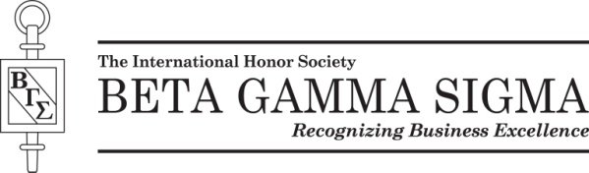

Beta Gamma Sigma and the Key logo are registered trademarks of Beta Gamma Sigma, Inc.

